Experimental procedure:

**Recirculating fluidized bed**

The Set up consists of the following major parts:

1. **Clear Perspex Cylinder** having inner **diameter of 20 cm and height 2 m.**

2. **Clear perspex Downcomer** box mounted on top of the cylinder and having a hose connected to the cylinder to recirculate the particles back into the cylinder.

**Process the set-up must accomplish:**

The cylinder is initially filled with sand particles, which are later fluidised when air enter the cylinder from bottom.

The sand particles flowing out of the cylinder will be collected into the downcomer box and sent back to the cylinder.

**Rubber hose will be connecting the tubes jutting out from the downcomer box and the cylinder. The particles collected in the box will be sent back to the cylinder via this hose.**

**The bottom plane of the downcomer box is tilted at two angles as shown below. One with respect to x axis and the other with respect to y axis. Both are at 25 degrees. This makes the point shown below the lowest point in the plane. Hence, particles collected in the box can easily flow down from this point.**

**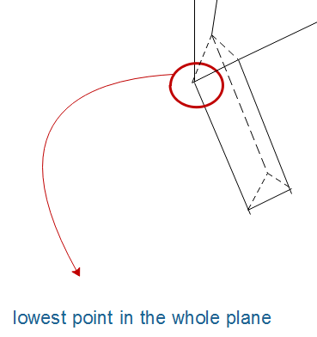  
This is the Downcomer corner in the bottom sheet of the box**

**List of main parts/ requirements:**

1. **Fluidized column with distributor with fine perforations and small pitch for uniform velocity at inlet**
2. **All the flanges/ valves/ nuts/ bolts etc. at bottom of column with distributor. (distributor system must be complete so that we only need to connect our compressor)**
3. **Set of Air-rotameters along with fittings, so that we can measure from 4mm/s to 20m/s of air velocity at inlet.**
4. **Pressure gauge to check pressure in compressor line**
5. **Downcomer Box/ collector**
6. **Metal Stand for column**
7. **Metal Stand for box**
8. **Clear/ transparent rubber hose with good elasticity to connect pipe coming down from box with pipe at bottom of column.**
9. **There should be no holes/ leakage from the column**